|  |  |
| --- | --- |
| ***Name*** | ***Abdullah Taufiq*** |
| ***Sap – Id*** | ***29121*** |
| ***Course*** | ***BSCS 4*** |
| ***Topic*** | ***Documentation Of Web Programming*** |

***Online Food Delivery Website***

*.*

***ABSTRACT***

*A technique called the online food delivery service will assist businesses in streamlining and controlling their establishments.For the waiters, it is making life easier because they don't have to go kitchen and give the orders to chef easily.*

*For the management point of view, the manager will able to control the restaurant by having all the reports to hand and able to see the records of each employees and orders.*

*This application helps the restaurants to do all functionalities more accurately and enhances the speed of all the tasks. Online Food Delivery System reduces manual works and improves efficiency of restaurant.*

*The online food delivery system set up menu online and the customers easily places the order with a simple mouse click. Also with a food menu online you can easily track the orders, maintain customer's database and improve your food delivery service. This system allows the user to select the desired food items from the displayed menu. The user orders the food items.*

***Proposed System***

*This online application enables the end users to register online, select the food from the e-menu card, read the E-menu card and order food online. By just selecting the food that the user wants to have. The results after selecting the food from the E-menu card will directly appear in the screen near the Chef who is going to cook the food for you. By using this system, the work of the Waiter is reduced and we can also say that the work is nullified. The benefit of this is that if there is rush in the Restaurant then there will be chances that the waiters will be unavailable and the users can directly order the food to the chef online by Using this system. The user will be given a username and a password to login.*

***Functional Requirements***

***1. Registration***

*If customer wants to order the food then he/she must be registered, unregistered user can't go for ordering.*

***2. Login***

*The customer login to the system by entering valid user id and password for ordering.*

***3. Display the menu***

*In the system all the items are displayed with their rates.*

***4. Select food item/s***

*Items are selected customer feel free to order.*

***Non-Functional Requirements***

***1. Availability***

*The system should be available at all times, meaning the user can access it using a web browser, only restricted by the down time of the server on which the system runs.*

***2. Safety***

*Data in the database of system should not loss or damage.*

***3. Maintainability***

*A commercial database is used for maintaining the database and the application server takes care of the site.*

***4. User friendly***

*System should be easily used by the customer.*

***5. Performance***

*Performance should be fast.*

***Operations Performed***

*We Used Crud Operations in Our Website.*

* *Customer Data*
* *Delete Customer and admin data*
* *Update customer and admin data*
* *Fetch Operation*

***Outputs’***

***Database:***

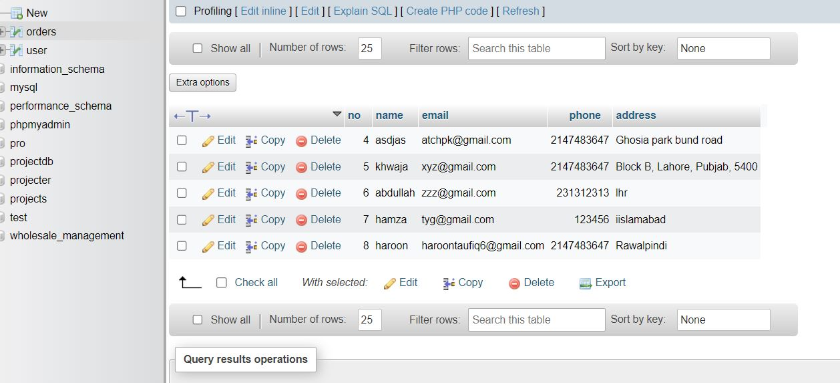

***Admin Page***

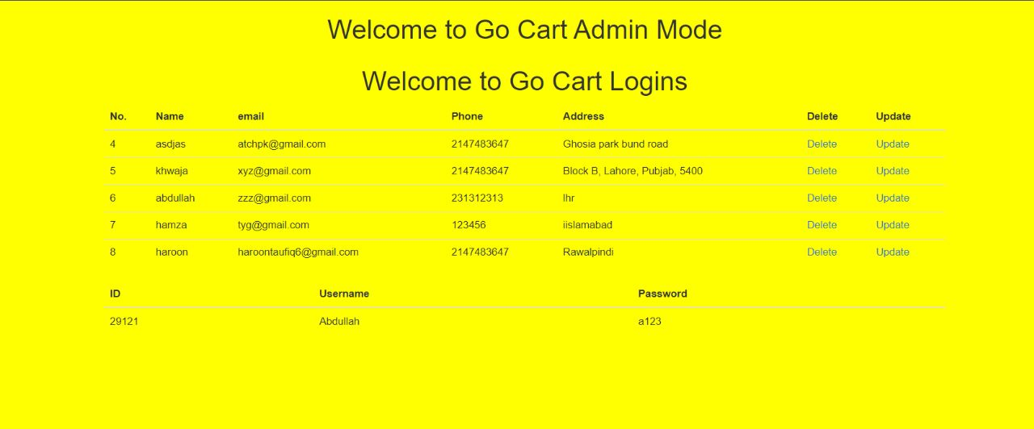

***Main Page***

